Full-Stack Engineer - Case Study
Plate Scan & Case Matching Service
Focus areas: full-stack problem-solving, Python API design, PostgreSQL, multi-tenancy & access control, and AWS deployment
Please read this whole document before you start.
This is a scoped-down, self-contained exercise - it is not a request to build the full production system. Sections 2 and 3 tell you exactly what to build and, just as importantly, what you can skip or mock.

1. Background
This case study is based on a real class of problem from the vehicle-recovery industry. To keep the exercise self-contained, we'll refer to the company behind it simply as “the Client.”
The Client is building a License Plate Recognition (LPR) platform for the vehicle-recovery(repossession) industry. Recovery agencies mount LPR cameras on their trucks; as agents drive their routes, the cameras continuously scan the plates of parked and passing vehicles. Every scan is checked against what the agency is looking for, and every scan is kept - even ones that don't match anything today can turn out to matter once a new case shows up for that vehicle tomorrow.
The platform is multi-tenant: many independent recovery agencies use the same platform, each with their own trucks, cameras, staff, and cases. An agency should never be able to see another agency's scans or cameras, aside from one deliberate exception around claiming new cases (details in Section 3.2), should not be able to see or touch another agency's cases either. Getting that boundary right is one of the things we care about most in this exercise.
Two flows drive almost everything the platform does:
- New case flow — a truck camera scans a plate the agency doesn't have an active case for yet. Before the agency can act on it, the platform has to confirm — through an external partner network that talks to the lender's system of record — that the vehicle is still eligible for repossession. If it is, a case is opened and an agent can claim it.
- Existing case flow — the agency already has a case for a VIN, assigned to them by a lender or forwarder. The platform searches its own scan history for that VIN and surfaces every prior sighting, so the agent has a trail of locations that helps narrow down where to look.
This case study asks you to build a small, self-contained slice of that system — the part that ingests a scan, decides which of the two flows it belongs to, and exposes the result to a tenant-scoped dashboard.

2. The exercise

2.1 Completion
Please complete this before your 1st round of Interview. We would like to see a smaller set of things done thoughtfully, with clear notes on what you'd do next, than every box half-checked.

2.2 What you're building & hosting
A small full-stack service called the Plate Scan & Case Matching Service:
- A Python backend exposing a REST API (framework of your choice — FastAPI, Flask, Django REST Framework, etc.)
- A PostgreSQL database you design
- A small front-end dashboard in Angular or React (your choice)
- Best-suited AWS service to host(no need to actually host it for this exercise)

2.3 Deliverables
- Code, as a link to a Git(or any) repository (public, or provide access to below email addresses)
Emails: hanumantharao.kamani@archetypegrowth.com ; priyanka.kundelu@archetypegrowth.com
- A README covering: how to run it locally, any assumptions you made, and what's incomplete or simplified.
- A short design note (1–2 pages is plenty) covering your database schema (an ER diagram or even a hand-drawn photo is fine), your multi-tenancy / access-control approach, and a sketch of how you'd deploy and scale this for real on AWS.
- Readiness to walk through it live — in the interview, you'll be asked to explain the decisions you made, not just demo that it runs.

3. What to build

3.1 Data model — concepts to design a schema around
Design the PostgreSQL schema yourself. At minimum it needs to represent these concepts — field names, types, keys, and indexes are your call:
Concept | Represents
Tenant | A recovery agency using the platform.
User | A staff member / agent, belonging to exactly one tenant, with a role (e.g. staff, admin).
Camera | A truck-mounted camera, belonging to exactly one tenant. This is how an inbound scan — which carries no login — gets attributed to a tenant.
Case | A VIN being tracked for recovery. Status pending_claim (not yet tied to a specific tenant — open for any tenant to claim), active (claimed by exactly one tenant), or closed.
Scan | A single plate/VIN sighting: camera_id, plate, vin, latitude/longitude, timestamp, image_url. Stored regardless of whether it matches a case.

3.2 API endpoints to implement
Build these four endpoints. Together they cover both flows described in Section 1.
1. POST /api/v1/scans — ingest a scan (simulates the camera)
This call is not authenticated — it stands in for a webhook fired by a camera, not a logged-in user. The tenant must be resolved from the camera_id in the payload. After storing the scan (every scan is stored, match or not), branch on whether the tenant already has an active case for that VIN:
- Active case exists → existing case flow: record that this VIN has been sighted again; this scan should now show up in that case's location trail.
- No active case → new case flow: call the provided mock eligibility endpoint (Appendix A). If it says the vehicle is still eligible for repossession, create a new Case in pending_claim status for that tenant.
2. POST /api/v1/cases/{case_id}/claim — claim a pending case
Authenticated. This is the one deliberate exception to tenant isolation: any authenticated staff user, from any tenant, can claim a pending_claim case - not just staff from the tenant whose camera originally scanned it. Claiming assigns the case to the claiming user's tenant and to that user as the agent, and moves it to active. Claiming a case that isn't pending_claim (already claimed, or closed) should fail clearly. The case should only be assigned to only one tenant not shared between tenants.
3. GET /api/v1/cases/{case_id}/scans — the location trail
Authenticated. Returns every scan on record for that case's VIN, ordered by time — this is the data that lets an agent narrow down where a vehicle has been seen.
4. GET /api/v1/cases — list cases
Authenticated. Returns the caller's own tenant's cases at every status, plus pending_claim cases from any tenant - since any tenant can claim them, they need to be visible in order to be claimed. Active and closed cases outside the caller's own tenant should never appear. Filterable by status (e.g. ?status=pending_claim).

3.3 Front-end dashboard
A small, functional (not polished) dashboard in Angular or React, for a logged-in staff user of one tenant:
- A list of the tenant's cases, with status.
- Clicking into a case shows its scan/location trail (a plain list is fine; plotting it on a map is a nice-to-have, not a requirement).
- A list of claimable pending_claim cases — including ones originated by other tenants — with a “Claim” action.

3.4 Explicitly out of scope — mock or skip these
To keep this to the time-box, please don't spend time building these — mock or stub them instead:
- Real camera integration — a plain REST POST simulates the camera webhook.
- Real partner-network / lender integration — a mock eligibility endpoint is provided for you (Appendix A). Don't build real repossession-eligibility logic.
- A real auth provider — a simple username/password login, or even a hardcoded user-per-tenant, is fine. We care about what happens after login, not the login mechanics themselves.
- Image upload/storage — an image_url string field is enough.
- Notifications — describe your approach with a note; no need to implement.
- Visual polish — functional and readable beats styled.

4. How the two flows fit together
The diagram below shows how the scoped exercise maps onto the two real-world flows from Section 1 — an incoming scan always gets stored, then is routed to either the existing-case location trail or the new-case eligibility check.
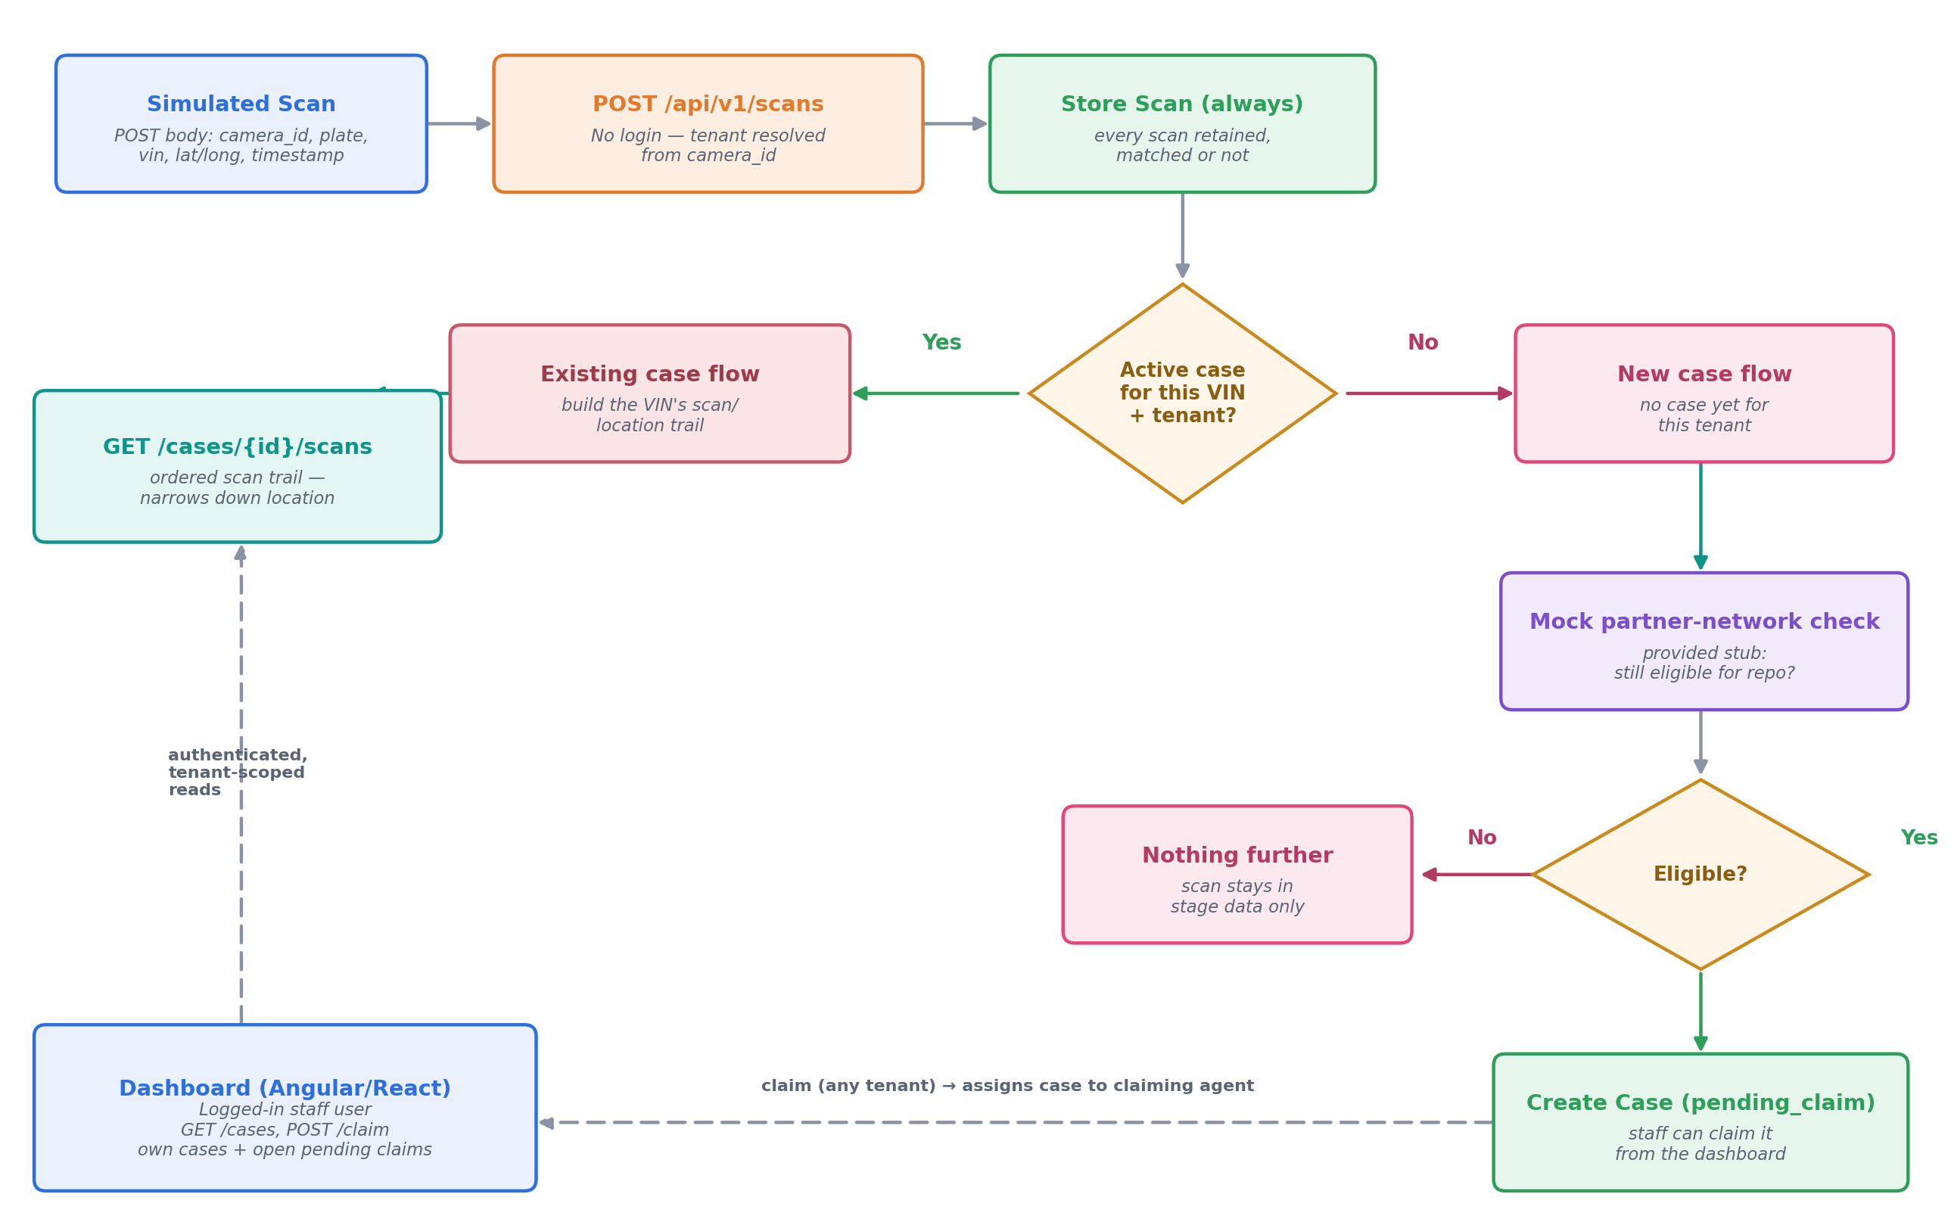
Note the dashed lines: the dashboard only ever talks to the authenticated, tenant-scoped GET/POST endpoints on the left and bottom — it never touches the ingest path directly.

5. Appendix

A. Mock eligibility endpoint (provided)
Treat this as an external service you can call — implement a trivial stub for it yourself (e.g. always return true, or alternate based on the VIN) so your new-case branch has something to call.
POST /mock/partner-network/eligibility
// Request
{ "vin": "1FTFW1E51NFA12345" }

// Response
{ "vin": "1FTFW1E51NFA12345", "still_eligible_for_repo": true }

B. Sample scan payload
POST /api/v1/scans
{
"camera_id": "cam_1001",
"plate": "7XYZ123",
"vin": "1FTFW1E51NFA12345",
"latitude": 33.7490,
"longitude": -84.3880,
"scanned_at": "2026-09-01T14:32:00Z",
"image_url": "https://example.com/scans/img_88213.jpg"
}

C. Suggested seed data
A small seed script or fixture makes both flows easy to demo. Two tenants is enough:
Tenant | Camera | Scenario to seed
Tenant A | cam_1001 | An existing active case for VIN 1FTFW1E51NFA12345, plus 2–3 older scans of that VIN from different locations/times — so a new scan exercises the existing-case flow.
Tenant B | cam_2050 | No case at all for VIN 5NPE34AF9KH123456 — so a new scan of it exercises the new-case flow end-to-end.

One thing worth seeding deliberately: claiming should work across tenants. For example, log in as Tenant A and claim the pending_claim case produced by Tenant B's scan (or vice versa) — it should succeed even though the case didn't originate from your own tenant's camera.

Questions?
If anything in this document is ambiguous, make a reasonable assumption, write it down in your README, and proceed. Handling ambiguity is itself part of what we're looking at. Let us know if you need any other information.
Best of luck!

